**INDUSTRY ORIENTED PROJECT TRAINING REPORT**

**HOSPITAL MANAGEMENT SYSTEM**

Submitted in partial fulfilment of the Requirements for the project training of degree of

**BACHELOR OF TECHNOGY**

In

**Computer Science & Engineering**



**AS PART OF COURSE WORK OF B.TECH (8TH SEM)**

**SUBMITTED BY**

DIVANSHU SHARMA

(CSE B)

1535450



**Affiliated to I.K. Gujral Punjab Technical University, Jalandhar**

**(BATCH: 2015-2019)**

**CERTIFICATE OF ORIGINALITY OF WORK**

I hereby certify that the work which is being presented in the project report entitled by **‘HOSPITAL MANAGEMENT SYSTEM’** in partial fulfillment of requirements for the award of degree of B.Tech Computer Science & Engineering submitted in the Department of Computer Science & Engineering at **CGC TECHNICAL CAMPUS, Jhanjeri, Mohali** under **I.K. Gujral** **PUNJAB TECHNICAL UNIVERSITY, JALANDHAR** is an authentic record of my own work under the supervision of **Mr. SABBIR POONAWALA**.

**DIVANSHU SHARMA**

**1535450**

**Date:**

This is to certify that the above statement made by the student is correct to the best of our knowledge and belief.

**Signature of the Supervisor**

**Mr. Sabbir Poonawala**

**Signature of H.O.D**

**Dr. Raman Chadha**

### **CERTIFICATE**

This is to certify that Ms. **DIVANSHU SHARMA** has completed the 6 Months Industrial Training during the period from FEB to MAY in our Organization as a Partial Fulfillment of Degree of Bachelor of Technology in Computer science & Engineering. She was trained in the field of **FULL STACK DEVELOPER.**

**Signature & Seal of Training Manager**

**DECLARATION**

I hereby declare that the work which is being presented in this project entitled **HOSPITAL MANAGEMENT SYSTEM** in partial fulfilment of degree of **Bachelor of Technology** in **COMPUTER SCIENCE AND ENGINEERING** is an authentic record of my own work carried out under the supervision and guidance of **Mr. Sabbir Poonawala, Trainer.**

I am fully responsible for the matter embodied in this project in case of any discrepancy found in the project and the project has not been submitted for the award of any other degree.

**DATE:**

**PLACE:**

**DIVANSHU SHARMA**

**ACKNOWLEDGEMENT**

For the successful completion of this project, I'd extend a sincere thanks to our project guide as well as trainer **Mr.** **Sabbir Poonawala** sir, who has been there with us while building the complete code from scratch. Without his guidance and teaching, it'd have been impossible of us to create the project.

I'm also grateful to our batch owners and people who've helped us out in every way possible, Shilpa Mahajani Ma’am, Mohit Kariya Sir, Gerard Thomas Sir and Komal Sanjay Pawar Ma’am. Without them, internship at such a huge company would have not been completed successfully. They ensured our smooth functioning and handled all the quirks and doubts while the sessions which helped us a lot in order to calmly finish the project.

I'd also like to thank **Dr. RAJNEESH TALWAR,** **Principal** CGC Technical Campus, Jhanjeri, Mohali and **MANAGEMENT** for providing encouragement and for giving us such an amazing opportunity to work in **COGNIZANT** through the college semester in order to get a corporate experience and education. It is only because of his thought that we were able to gain such a training with a parallel balance of college academics.

**DIVANSHU SHARMA**

**TABLE OF CONTENTS:**

|  |  |  |  |
| --- | --- | --- | --- |
| S. NO. | CHAPTER NO. | SUB TOPICS | PAGE NO. |
| 1. | Chapter-1 | ABOUT |  |
|  |  | 1.1. The company |  |
|  |  | 1.2. Purpose of this document |  |
| 2. | Chapter-2 | INTRODUCTION TO PROJECT |  |
|  |  | 2.1. Purpose |  |
|  |  | 2.2. Objectives |  |
|  |  | 2.3. Intended Audience |  |
| 3. | Chapter-3 | TECHNOLOGIES AND SOFTWARES |  |
|  |  | 3.1. Technologies |  |
|  |  | 3.2. Softwares |  |
| 4. | Chapter-4 | PROJECT OVERVIEW |  |
|  |  | 4.1. Problem Introduction |  |
|  |  | 4.2. Business Case |  |
|  |  | 4.3. Project Scope |  |
|  |  | 4.4. Modules |  |
|  |  | 4.5. Requirement Engineering |  |
| 5. | Chapter-5 | BUSINESS REQUIREMENTS |  |
|  |  | 5.1. High Level Requirements |  |
|  |  | 5.2. Detailed Business Requirements |  |
|  |  | 5.2.1. functional requirements |  |
| 6. | Chapter-6 | ANALYSIS |  |
|  |  | 6.1. Hardware Requirements |  |
|  |  | 6.2. Software Requirements |  |
| 7. | Chapter-7 | TABLES |  |
|  |  | 7.1. Admin Table |  |
|  |  | 7.2. Patient Table |  |
|  |  | 7.3. Physician Table |  |
|  |  | 7.4. Diagnosis Table |  |
| 8. | Chapter-8 | SCREENSHOTS |  |
|  |  | 8.1. User Interface |  |
| 9. | Chapter-9 | CONCLUSION & REFERENCES |  |

**LIST OF FIGURES:**

|  |  |  |
| --- | --- | --- |
| S. NO. | NAME OF FIGURE | PAGE NO. |
| 1. | Welcome Page 1 |  |
| 2. | Welcome Page 2 |  |
| 3. | Admin Registration Form |  |
| 4. | Admin Home Page |  |
| 5. | Register New Patient |  |
| 6. | Patient Details |  |
| 7. | View Complete Patient Details |  |
| 8. | Update Patient Details |  |
| 9. | View Diagnosis Details |  |
| 10. | Update Diagnosis Details |  |
| 11. | Register New Physician |  |
| 12. | Physician Details |  |
| 13. | View Complete Physician Details |  |
| 14. | Update Physician Details |  |

**CHAPTER-1**

**ABOUT**

* 1. THE COMPANY

**Cognizant** is an American multinational corporation that provides IT services, including digital, technology, consulting, and operations services. It is headquartered in Teaneck, New Jersey, United States of America. Cognizant is included in the NASDAQ-100 and the S&P 500 indices. It is also one of the fastest growing Fortune 500 companies. It was founded as an in-house technology unit of DUN & BRADSTREEIN in 1994 and started serving external clients in 1996.

Cognizant had a period of fast growth during the 2000s, becoming a Fortune 500 company in 2011. In 2015, the FORTUNE Magazine named it as the world's fourth most admired IT Services company. In 2017, Cognizant was named in Fortune’s Future 50 list.

Cognizant provides information technology, information security, consulting, ITO and BPO services. These include business and technology consulting, system integration, application development & maintenance, IT infrastructure services, analytics, business intelligence data, warehousing, customer relationship management, supply chain management, engineering & manufacturing solutions, enterprise resource planning, research and development, outsourcing, and testing solutions.

The company has more than 281,600 employees globally, of which over 150,000 are in India across 10 locations with a plurality in Chennai. The other centers of the company are in Bangalore, Coimbatore, Gurgaon, Noida, Hyderabad, Kochi, Kolkata, Mangalore, Mumbai, and Pune. The company has local, regional, and global delivery centers in the UK, Hungary, The Netherlands, Spain, China, Philippines, Canada, Brazil, Argentina, Mexico etc.

Cognizant has three key practice areas that span its business — Digital Business, Digital Operations, and Digital Systems & Technology.

* 1. PURPOSE OF THIS DOCUMENT

This document is aimed at:

* Providing the necessary inputs to the detailed requirements gathering phase and further on for the SDLC processes.
* This document also serves to establish the traceability between the Business Objectives and the requirements identified in the proposed solution and how they satisfy the stated objectives.
* Provide expectation traceability in terms of the requirements and the user expectation
* Serves as a formal template for documenting the Business Requirements which also includes statutory and regulatory requirements.

The purpose of this document is to systematically capture requirements for the project and the system to be developed. Functional requirements are captured in this document. It also serves as the input for the project scoping.

**CHAPTER-2**

**INTRODUCTION TO PROJECT**

2.1. PURPOSE

Hospitals currently use a manual system for the management and maintenance of critical information. The current system requires numerous paper forms, with data stores spread throughout the hospital management infrastructure. Often information (on forms) is incomplete, or does not follow management standards. Forms are often lost in transit between departments requiring a comprehensive auditing process to ensure that no vital information is lost. Multiple copies of the same information exist in the hospital and may lead to inconsistencies in data in various data stores.

A significant part of the operation of any hospital involves the acquisition, management and timely retrieval of great volumes of information. This information typically involves: patient personal information, patient history, diagnosis details, physician details and searching for the physician. All of this information must be managed in an efficient and cost wise fashion so that an institution’s resources may be effectively utilized HMS will automate the management of the hospital making it more efficient and error free. It aims at standardizing data, consolidating data ensuring, data integrity and reducing inconsistencies.

2.2. OBJECTIVES

Below are the objectives that are fulfilled in this project:

Hospital Management system is a system used for enabling enrollment of patient, add physician, search for physician, update diagnosis details and view Patient history.

* Enroll Patient – Hospital Administrators to register a Patient into the system. The administrator is having the complete details of the patient to be entered into the system.
* Add Physician - Hospital Administrators to register a Physician into the system. The administrator is having the complete details of the physician to be entered into the system including his specialty and qualification details.
* Physician Search - Hospital Administrators search for Physician based on specified search criteria.
* Patient Diagnosis Details - Hospital Administrators to save the patients diagnosis details into the system.
* View Patient History – In case administrator wishes to view the patient case history details, he can retrieve all the past records of the patient.

2.3. INTENDED AUDIENCE

* All members of the project.
* Delivery Assurance Group.

**CHAPTER-3**

**TECHNOLOGIES AND SOFTWARES**

3.1. TECHNOLOGIES

* Java
* Maven
* Spring MVC
* Hibernate
* HTML
* CSS
* JavaScript
* Mockito
* JUnit
* Logger

3.2. SOFTWARES

* Apache Tomcat
* Oracle
* Eclipse

**CHAPTER-4**

**PROJECT OVERVIEW**

4.1. PROBLEM INTRODUCTON

**Lack of Immediate Retrievals:**

The information is very difficult to retrieve and to find particular information like- E.g. to find out about the patient’s history, the user has to go through various registers. This results in inconvenience and wastage of time.

**Lack of Immediate Information Storage:**

The information generated by various transactions takes time and efforts to be stored at the right place.

**Lack of Prompt Updating:**

Various changes to information like patient details or immunization details of patient are difficult to make as paper work is involved.

**Preparation of Accurate and Prompt Reports:**

This becomes a difficult task as information is difficult to collect from various registers.

4.2. BUSINESS CASE

A comprehensive healthcare management is necessary to drive a thriving enterprise. Hospital management needs to provide a robust framework to assure seamless daily operations at the enterprise level, which integrates the data from different departments within the hospital.

The solution developed will address the objective in a holistic manner and will have all the features and functionalities which shall let the hospital be able to record & assimilate data from the patients, doctors, lab diagnosis and correlate the data with the patient’s visit history. Parameter based search algorithm & transfer of patient records are scalable features.

4.3. PROJECT SCOPE

* Administrator fills up all the details of the patient as well as the physician in the system. His login is mandatory to view, modify or delete any data. If we have a new administrator then he will have to register himself into the system with all his details filled including his first name, last name, age, gender, password and email id.
* Patient is registered in the hospital by the administrator and his complete information including his first name, last name, age, gender, contact, email, address, city state and zip code is stored in the database. Whenever a new patient comes up his information is stored freshly.
* The same way physician is registered in the hospital by the administrator and his complete information including his first name, last name, age, gender, contact, email, address, city, state, zip code, degree, specialty and work hours are stored in the database. Whenever a new physician comes up in the hospital his information is stored freshly.
* Diagnosis details of the patients are stored in the system, so as if in any case he/she misplaces the report, the hospital has the record for his/her further treatment. This is the complete report of the patient’s health condition.
* Patient history can be viewed; this includes all the previous treatments the patient has undergone.

All the work is done manually by the administrator. Patient and the doctors don’t need to remember the treatment patient has taken and the previous records, everything is kept safe in the system to prevent it from loss.

4.4. MODULES

The entire project mainly consists of modules:

* Admin Module
* Patient Module
* Physician Module
* Diagnosis Module
* Patient History Module

**Admin Module**

* Register Patients.
* Register Physicians.
* View Patient History.
* View Diagnosis Details.
* Edit Patient Record.
* Edit Physician Record.
* Enter Diagnosis Details after every Treatment.
* Carefully save all the data into the system.

**Patient Module**

* Detailed patient Information.
* From here we can view and edit patient records.

**Physician Module**

* Detailed physician Information.
* From here we can view and edit physician records.

**Diagnosis Module**

* Contains patient Diagnosis Details.
* Diagnosis details can be viewed or edited from here.
* Detailed information for any future need.

**Patient History Module**

* Contains patient record.
* All the previous visits with his/her diagnosis details will be shown.

4.5. REQUIREMENT ENGINEERING

Systematic requirements analysis is also known as requirements engineering. It is sometimes referred to loosely by names such as requirements gathering, requirements capture, or requirements specification. The term requirements analysis can also be applied specifically to the analysis proper, as opposed to elicitation or documentation of the requirements, for instance. Requirements engineering can be divided into discrete chronological steps:

* Requirements elicitation,
* Requirements analysis and negotiation,
* Requirements specification,
* System modeling,
* Requirements validation,
* Requirements management.

Systems engineering and software engineering that is concerned with determining the goals, functions, and constraints of hardware and software systems. In some life cycle models, the requirement engineering process begins with a feasibility study activity, which leads to a feasibility report. If the feasibility study suggests that the product should be developed, then requirement analysis can begin. The requirement engineering provides the appropriate mechanism for Requirement engineering according to Laplante (2007) is "a sub discipline of understanding what customer wants.

**CHAPTER-5**

**BUSINESS REQUIREMENTS**

5.1. HIGH LEVEL BUSINESS REQUIREMENTS

|  |  |  |  |
| --- | --- | --- | --- |
| S. No. | Business Requirement ID | Short Description | Description in Detail |
| 1. | Req_1 | Admin Registration | Ability of the system to procure the fundamental details of the admin. |
| 2. | Req_2 | Admin Authentication | Ability of the system to authenticate the credentials of the registered Admin. |
| 3. | Req_3 | Create Patient Records | Ability of the system to ADD new Patient. Update the patient records according to the need of the patient in case any detail is filled incorrectly. |
| 4. | Req_4 | Create Physician Records | Ability of the system to ADD new Physician. Update the physician records according to the need of the physician in case any detail is filled incorrectly. |
| 5. | Req_5 | Search Physician | Ability of the system to set amenities for the create contract. |
| 6. | Req_6 | Patient Diagnosis Details | Ability of the system to UPDATE the patient Diagnosis details. |
| 7. | Req_7 | View Patient History | Ability of the system to view complete Patient History. |
| 8. | Req_8 | Admin Log Off | Ability of the system to enable Admin to Log Off. |

5.2. DETAILED BUSINESS REQUIREMENTS

**5.2.1**. **Functional Requirements**

The Requirements in this document are prioritized as follows:

|  |  |  |
| --- | --- | --- |
| **Value** | **Rating** | **Description** |
| 1 | Critical | This requirement is critical to the success of the project. The project will not be possible without this requirement. |
| 2 | High | This requirement is high priority, but the project can be implemented at a bare minimum without this requirement. |
| 3 | Medium | This requirement is somewhat important, as it provides some value but the project can proceed without it. |
| **Value** | **Rating** | **Description** |
| 4 | Low | This is a low priority requirement, or a “nice to have” feature, if time and cost allow it. |
| 5 | Future | This requirement is out of scope for this project, and has been included here for a possible future release. |

Detailed Description Table:

|  |  |  |  |  |  |
| --- | --- | --- | --- | --- | --- |
| **Req.** | **Rationale Categorization** | **Business Requirement** | **Priority** | **BR Traced to Business Requirement / Use case ID** | **Impacted Stakeholders** |
| 1.1. | Admin  Registration | When the Admin clicks on the registration link, it should re-direct to registration form. | Critical | Req_1 |  |
| 1.2. | Admin  Registration | Admin needs to fill some of the basic attributes/fields as  mentioned below in requirement: First Name, Last Name,  Age, Gender, Contact Number, Vendor Id,  Password. | Critical | Req_1 | Please refer to  Table 7.1. |
| 1.3. | Admin  Registration | Clicking ‘Submit’ should validate the datatype constraints for each field. | Critical | Req_1 |  |
| 1.4. | Admin  Registration | Admin failing to provide information on the mandatory  fields be provided with an alert message – ‘Please update the  highlighted mandatory field(s).’ Highlight the missed out field in red. | Medium | Req_1 |  |
| **Req.** | **Rationale Categorization** | **Business Requirement** | **Priority** | **BR Traced to Business Requirement / Use case ID** | **Impacted Stakeholders** |
| 1.5. | Admin  Registration | Post-successful field level validation, save the information in the database. | Critical | Req_1 |  |
| 1.6. | Admin  Registration | Upon saving the information in the  database, display  the message ‘Your details are submitted successfully’. | Medium | Req_1 |  |
| 2.1. | Credential Authentication | A registered user – is able to click ‘Login’ link, after keying in  ‘Admin ID’ & ‘Password’ field and get his credentials  authenticated with the existing database entry. | Critical | Req_2 |  |
| 3.1. | Create Patient records | On clicking “Create Patient Record”, it should redirect Admin to the Patient Record  Creation Page. | Critical | Req_3 |  |
| 3.2. | Create Patient records | Admin should be able to update the mandatory fields of the Patient. | Critical | Req_3 | Please refer to  Table 7.2. |
| 3.3. | Create Patient records | Clicking ‘Submit’ should validate the datatype constraints for each field. | Critical | Req_3 |  |
| **Req.** | **Rationale Categorization** | **Business Requirement** | **Priority** | **BR Traced to Business Requirement / Use case ID** | **Impacted Stakeholders** |
| 3.4. | Create Patient records | Admin failing to provide information on the mandatory fields be provided with an alert message – ‘Please update the highlighted mandatory field(s).’ Also, highlight the missed out field in red. | Critical | Req_3 |  |
| 3.5. | Create Patient records | Post-successful field level validation, save the information in the database. | Critical | Req_3 |  |
| 3.6. | Create Patient records | Upon saving the information in the database, display the message ‘Your details are submitted successfully’. | Critical | Req_3 |  |
| 4.1. | Create Physician Records | On clicking “Create Physician Record”, it should redirect Admin to the Physician Record Creation Page. | Critical | Req_4 |  |
| 4.2. | Create  Physician  Records | Admin should be able to update the mandatory fields of the Physician. | Critical | Req_4 | Please refer to  Table 7.3. |
| 4.3. | Create  Physician  Records | Clicking ‘Submit’ should validate the datatype constraints for each field. | Critical | Req_4 |  |
| **Req.** | **Rationale Categorization** | **Business Requirement** | **Priority** | **BR Traced to Business Requirement / Use case ID** | **Impacted Stakeholders** |
| 4.4. | Create  Physician  Records | Admin failing to provide information on the mandatory fields be provided with an alert message – ‘Please update the highlighted mandatory field(s).’ Also, highlight the missed out field in red. | Critical | Req_4 |  |
| 4.5. | Create  Physician  Records | Post-successful  field level validation, save the information in the database. | Critical | Req_4 |  |
| 4.6. | Create  Physician  Records | Upon saving the information in the database, display the message ‘Your details are submitted successfully’. | Critical | Req_4 |  |
| 5.1. | Search Physician | When Admin clicks the link “Search  Physician”, it should display all the Physicians present in the Database. | Critical | Req_5 |  |
| 5.2. | Search Physician | When Admin clicks the link “Search  Physician”, and with specific search criteria, then it should display the list of Physicians satisfying the search criteria. | Critical | Req_5 |  |
| **Req.** | **Rationale Categorization** | **Business Requirement** | **Priority** | **BR Traced to Business Requirement / Use case ID** | **Impacted Stakeholders** |
| 6.1. | Patient  Diagnosis  Details | When Admin clicks  “Add Patient Diagnosis Details” link, Admin should be redirected to creation page. | Critical | Req_6 |  |
| 6.2. | Patient  Diagnosis Details | Admin should be able to update the mandatory fields of the Patient. | Critical | Req_6 | Please refer to  Table 7.4. |
| 6.3. | Patient  Diagnosis Details | Clicking ‘Submit’ should validate the datatype constraints for each field. | Critical | Req_6 |  |
| 6.4. | Patient  Diagnosis Details | Admin failing to provide information on the mandatory fields be provided with an alert message – ‘Please update the highlighted mandatory field(s).’ Also, highlight the missed out field in red. | Critical | Req_6 |  |
| 6.5. | Patient  Diagnosis Details | Post-successful  field level validation, save the information in the database. | Critical | Req_6 |  |
| 6.6. | Patient  Diagnosis Details | Upon saving the information in the database, display the message ‘Your details are submitted successfully’. | Critical | Req_6 |  |
| **Req.** | **Rationale Categorization** | **Business Requirement** | **Priority** | **BR Traced to Business Requirement / Use case ID** | **Impacted Stakeholders** |
| 7.1. | View Patient  History | When Admin clicks  “View Patient  History” link, the system should list all the available patient ID and patient name. | Critical | Req_7 |  |
| 7.2. | View Patient  History | On clicking the  Patient ID, it should display the Patient History. | Critical | Req_7 |  |
| 8.1. | Admin Log off | Option to log off from the system. | Critical | Req_8 |  |

**CHAPTER-6**

**ANALYSIS**

6.1. HARDWARE REQUIREMENTS

* Desktop PC with 8GB RAM.

6.2. SOFTWARE REQUIREMENTS

* Eclipse IDE for Java EE Developers (Oxygen)
* Maven 3.6.0
* Tomcat 8.0
* Oracle 11g express version

**CHAPTER-7**

**TABLES**

7.1. ADMIN TABLE

|  |  |  |  |  |
| --- | --- | --- | --- | --- |
| **Field** **Name** | **Field Type** | **Data Type** | **Mandatory** | **Possible Values** |
| Admin ID | Text(10) | Alphabetic | Yes | System Generated |
| First Name | Text(50) | Alphabetic | Yes |  |
| Last Name | Text(50) | Alphabetic | Yes |  |
| Age | Numeric(2) | Numeric | Yes |  |
| Gender | Drop Down | NA | Yes | Male,  Female |
| DOB | Text(10) | Alphanumeric | Yes |  |
| Contact Number | Text(10) | Numeric | Yes |  |
| Alt Contact Number | Text(10) | Numeric | No |  |
| Email ID | Text(50) | Alphanumeric | Yes |  |

7.2. PATIENT TABLE

|  |  |  |  |  |
| --- | --- | --- | --- | --- |
| **Field** **Name** | **Field Type** | **Data Type** | **Mandatory** | **Possible Values** |
| Patient ID | Text(10) | Alphanumeric | Yes | System Generated |
| First Name | Text(50) | Alphabetic | Yes |  |
| Last Name | Text(50) | Alphabetic | Yes |  |
| Age | Numeric(2) | Numeric | Yes |  |
| Gender | Drop Down | NA | Yes | Male,  Female |
| DOB | Text(10) | Alphanumeric | Yes |  |
| Contact Number | Text(10) | Numeric | Yes |  |
| Alt Contact Number | Text(10) | Numeric | No |  |
| **Field** **Name** | **Field Type** | **Data Type** | **Mandatory** | **Possible Values** |
| Email ID | Text(50) | Alphanumeric | Yes |  |
| Password | Text(15) | Alphanumeric | Yes |  |
| Address Line 1 | Text(100) | Alphanumeric | Yes |  |
| Address Line 1 | Text(100) | Alphabetic | Yes |  |
| City | Text(50) | Alphabetic | Yes |  |
| State | Text(50) | Alphabetic | Yes |  |
| Zip Code | Text(10) | Numeric | Yes |  |

7.3. PHYSICIAN TABLE

|  |  |  |  |  |
| --- | --- | --- | --- | --- |
| **Field Name** | **Field Type** | **Data Type** | **Mandatory** | **Possible Values** |
| Physician ID | Text(10) | Alphanumeric | Yes | System Generated |
| First Name | Text(50) | Alphabetic | Yes |  |
| Last Name | Text(50) | Alphabetic | Yes |  |
| Age | Numeric(2) | Numeric | Yes |  |
| Gender | Drop Down | NA | Yes | Male,  Female |
| DOB | Text(10) | Alphanumeric | No |  |
| Contact Number | Text(10) | Numeric | Yes |  |
| Alt Contact Number | Text(10) | Numeric | No |  |
| Email ID | Text(50) | Alphanumeric | Yes |  |
| Password | Text(15) | Alphanumeric | Yes |  |
| Address Line 1 | Text(100) | Alphanumeric | Yes |  |
| Address Line 2 | Text(100) | Alphabetic | No |  |
| City | Text(50) | Alphabetic | Yes |  |
| **Field Name** | **Field Type** | **Data Type** | **Mandatory** | **Possible Values** |
| State | Text(50) | Alphabetic | Yes |  |
| Zip Code | Text(10) | Numeric | Yes |  |
| Degree | Text(50) | Alphabetic | Yes |  |
| Specialty | Text(50) | Alphabetic | Yes |  |
| Work hours | Drop down | NA | Yes |  |
| Hospital/Clinic  Name | Text(100) | Alphanumeric | Yes |  |

7.4. DIAGNOSIS DETAILS

|  |  |  |  |  |
| --- | --- | --- | --- | --- |
| **Field Name** | **Field Type** | **Data Type** | **Mandatory** | **Possible Values** |
| Report ID | Numeric(10) | Numeric | Yes | System Generated |
| Patient ID | Text(10) | Alphanumeric | Yes | System Generated |
| Physician ID | Text(10) | Alphanumeric | Yes | System Generated |
| Service date | Text(10) | Alphanumeric | Yes |  |
| Test  Result date | Text(10) | Alphanumeric | Yes |  |
| Diag 1 –  Actual  Value | Numeric(10) | Numeric | Yes |  |
| Diag 1 –  Normal  Range | Numeric(10) | Numeric | Yes |  |
| Diag 2 –  Actual  Value | Numeric(10) | Numeric | No |  |
| Diag 2 –  Normal  Range | Numeric(10) | Numeric | No |  |
| Diag 3 –  Actual  Value | Numeric(10) | Numeric | No |  |
| **Field Name** | **Field Type** | **Data Type** | **Mandatory** | **Possible Values** |
| Diag 3 –  Normal  Range | Numeric(10) | Numeric | No |  |
| Diag 4 –  Actual  Value | Numeric(10) | Numeric | No |  |
| Diag 4 –  Normal  Range | Numeric(10) | Numeric | No |  |
| Diag 5 –  Actual  Value | Numeric(10) | Numeric | No |  |
| Diag 5 –  Normal  Range | Numeric(10) | Numeric | No |  |
| Diag 6 –  Actual  Value | Numeric(10) | Numeric | No |  |
| Diag 6 –  Normal  Range | Numeric(10) | Numeric | No |  |
| Physician  Comments | Text(300) | Alphabetic | Yes |  |
| Other info | Text(300) | Alphabetic | No |  |

**CHAPTER-8**

**SCREENSHOTS**

8.1. User Interface

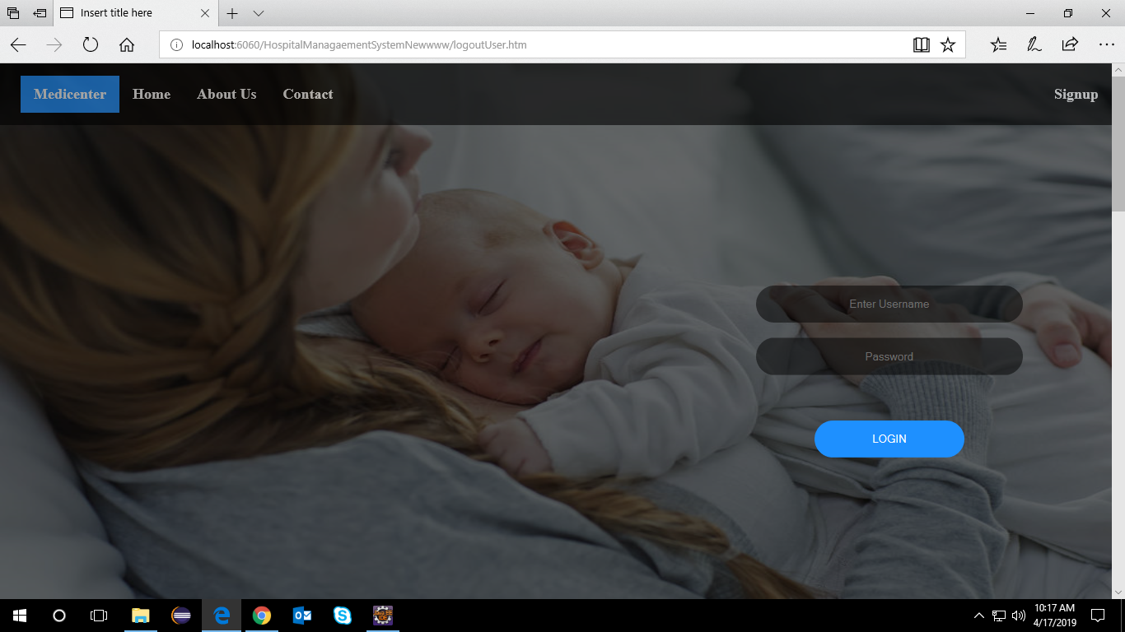

**FIG 1: Welcome Page 1**

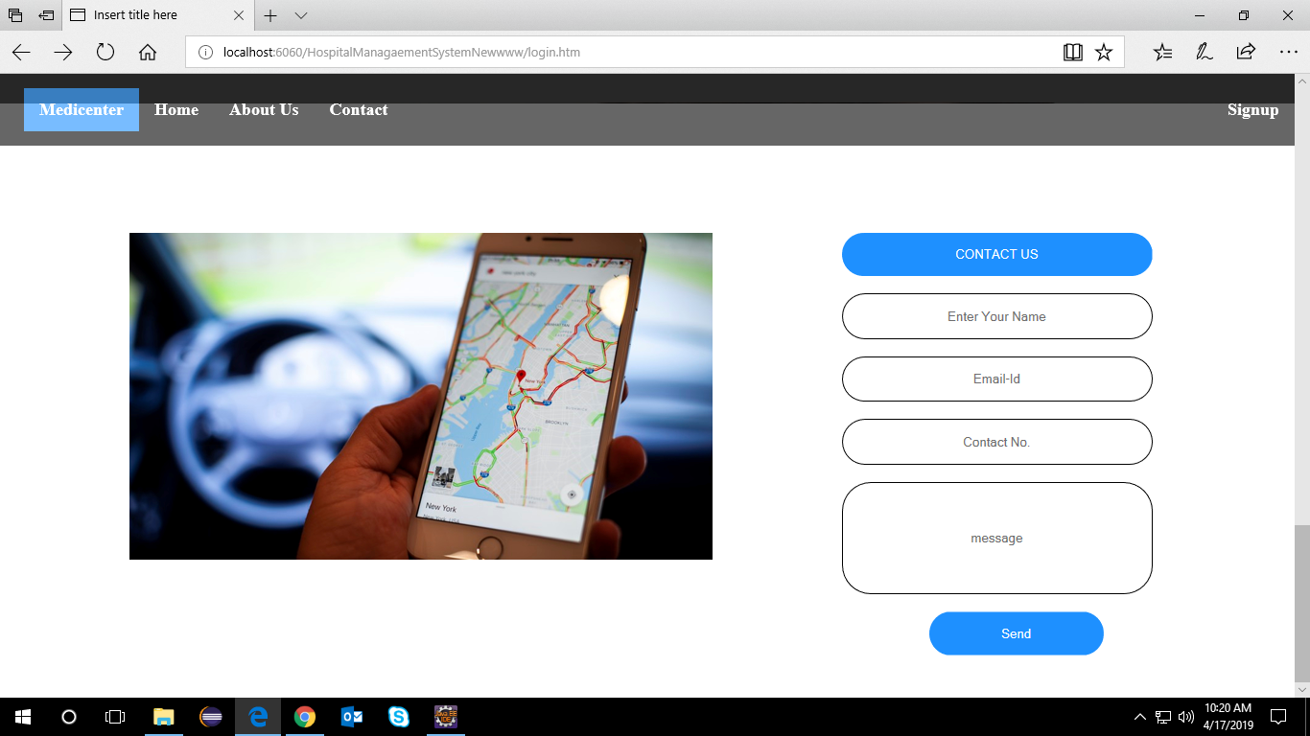

**FIG 2: Welcome Page 2**(Contact)

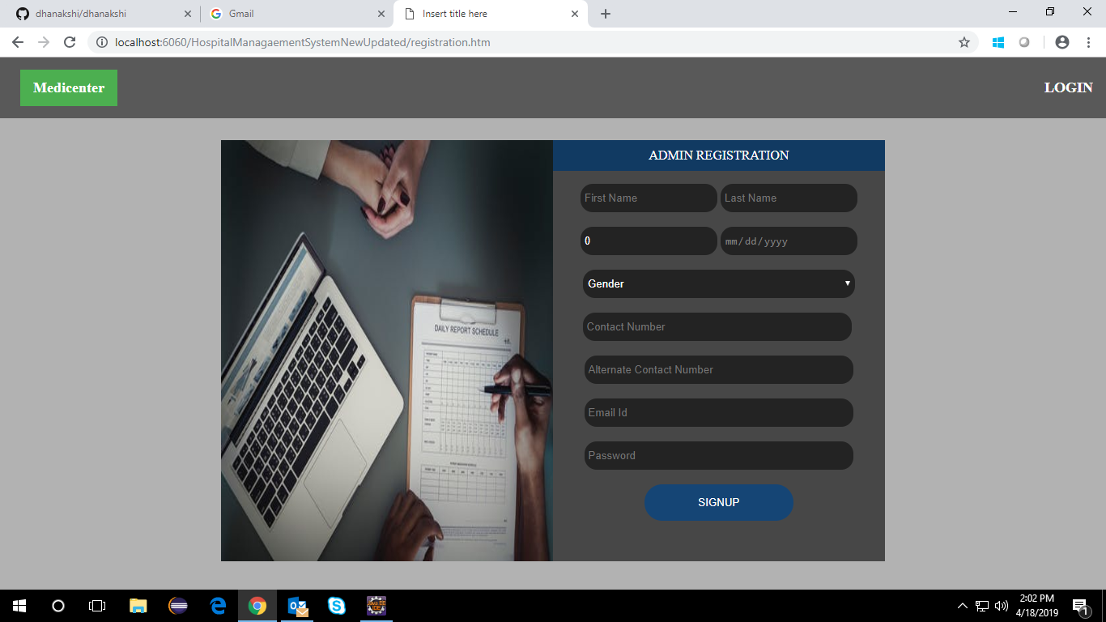

**FIG 3: Admin Registration Form**

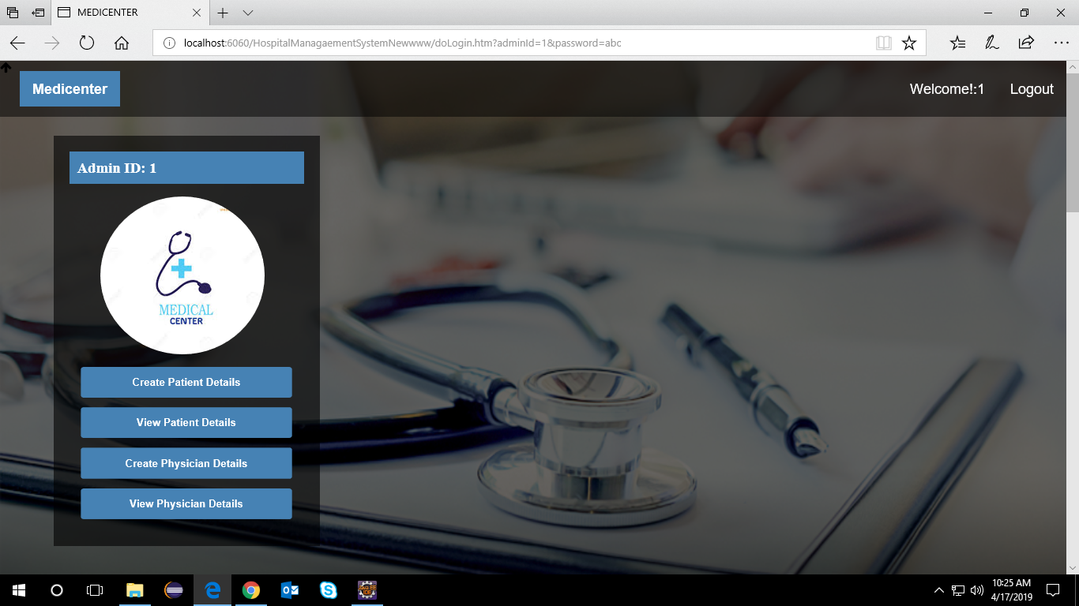

**FIG 4: Admin Home Page**

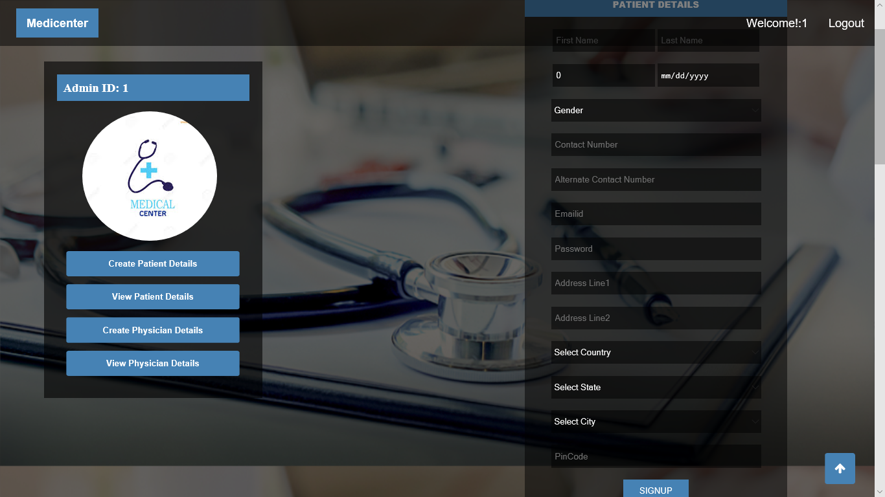

**FIG 5: Register New Patient**

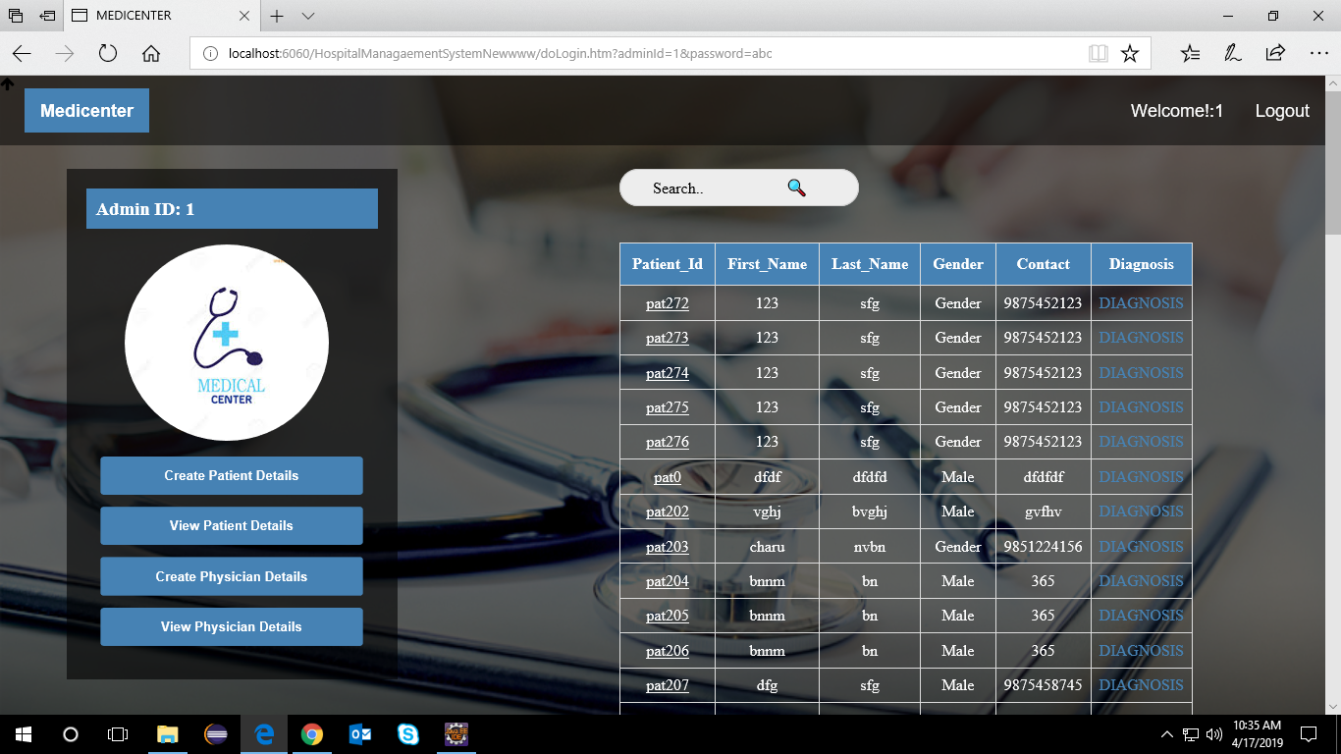

**FIG 6: Patient Details**

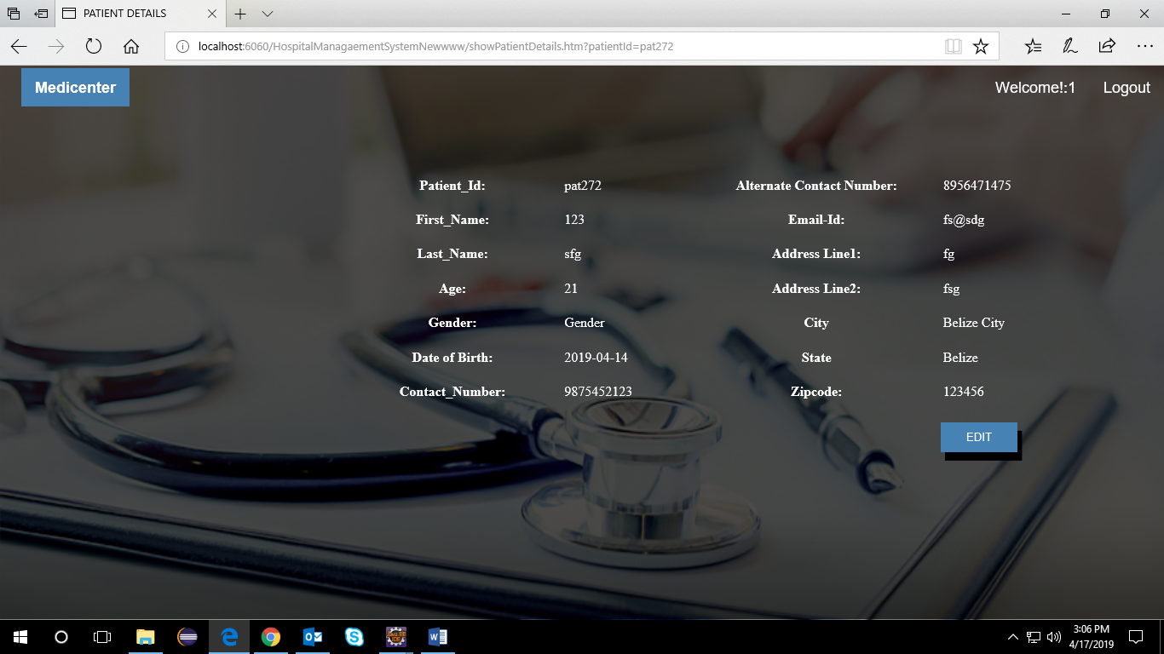

**FIG 7: View Complete Patient Details**

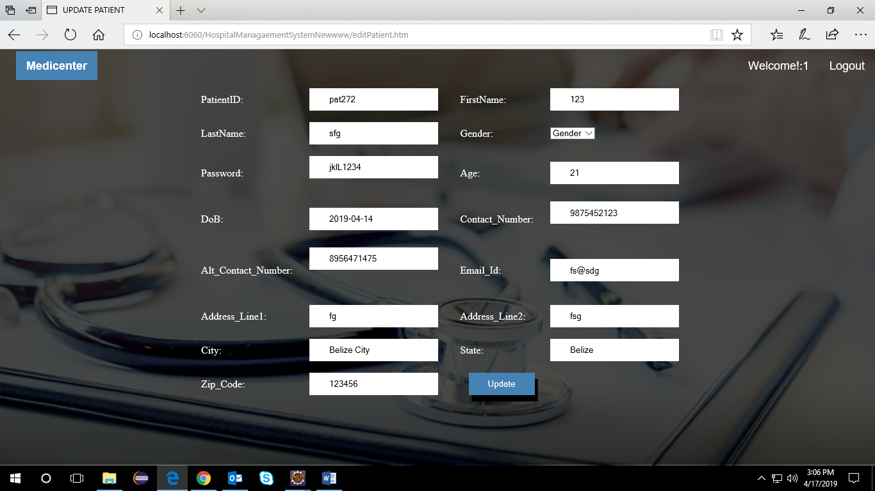

**FIG 8: Update Patient Details**

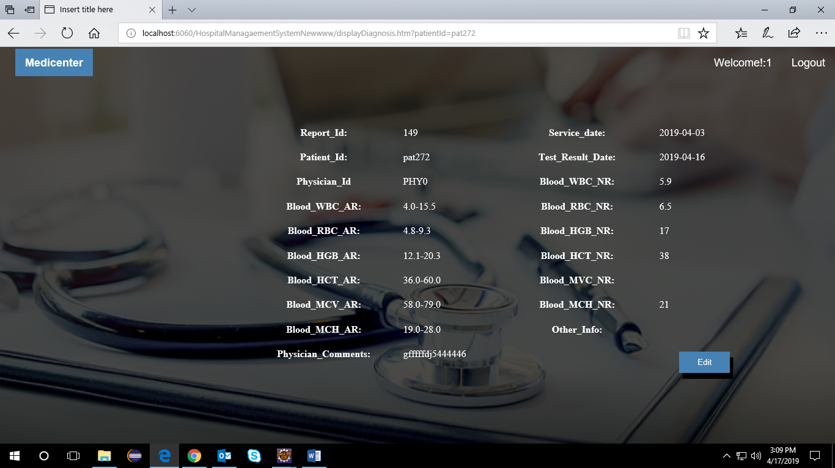

**FIG 9: View Diagnosis Details**

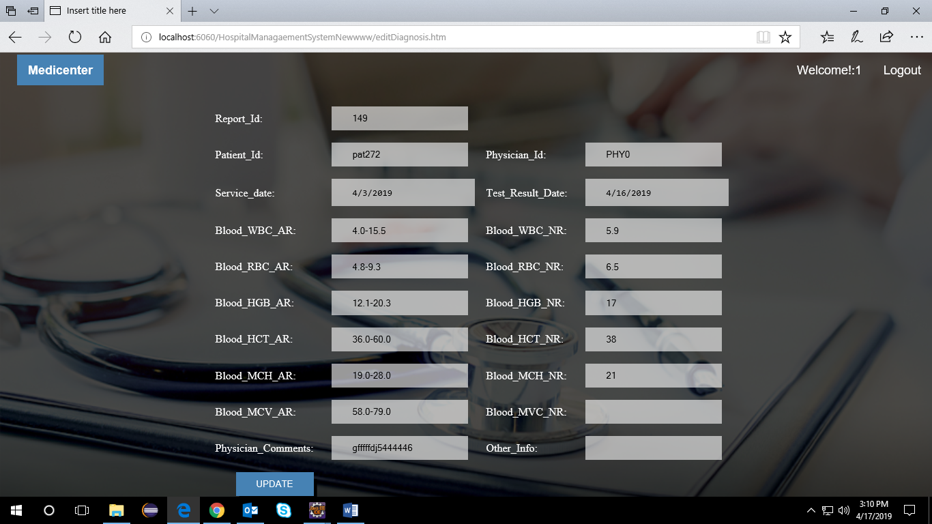

**FIG 10: Update Diagnosis Details**

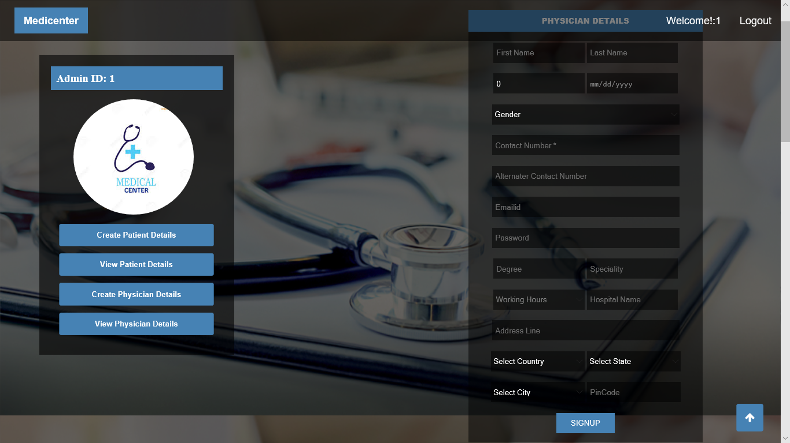

**FIG 11: Register New Physician**

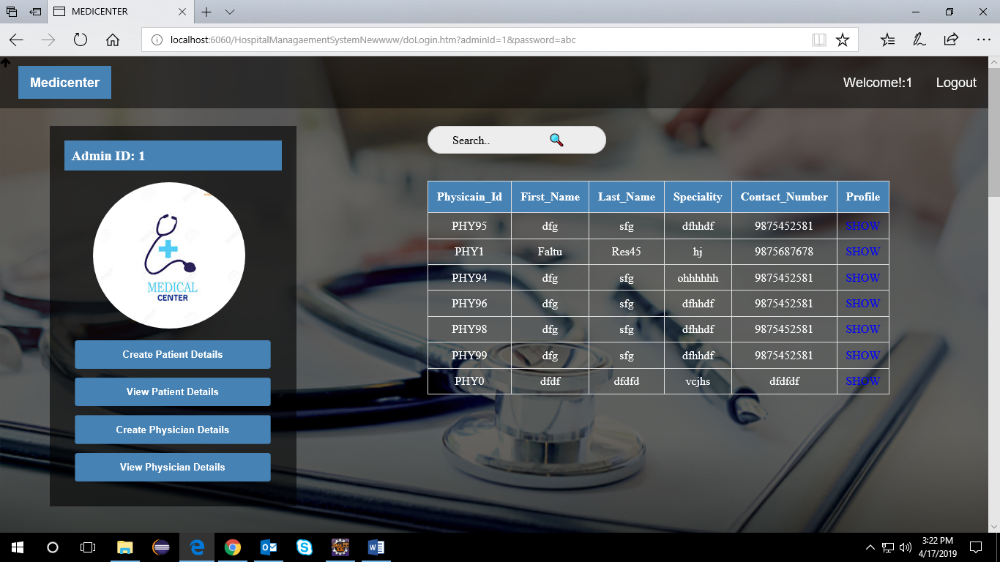

**FIG 12: Physician Details**

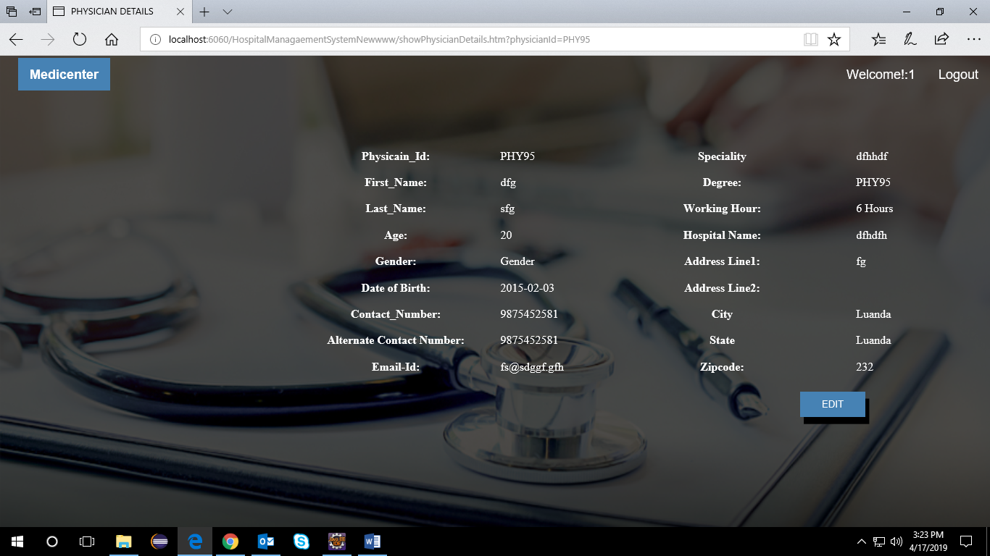

**FIG 13: View Complete Physician Details**

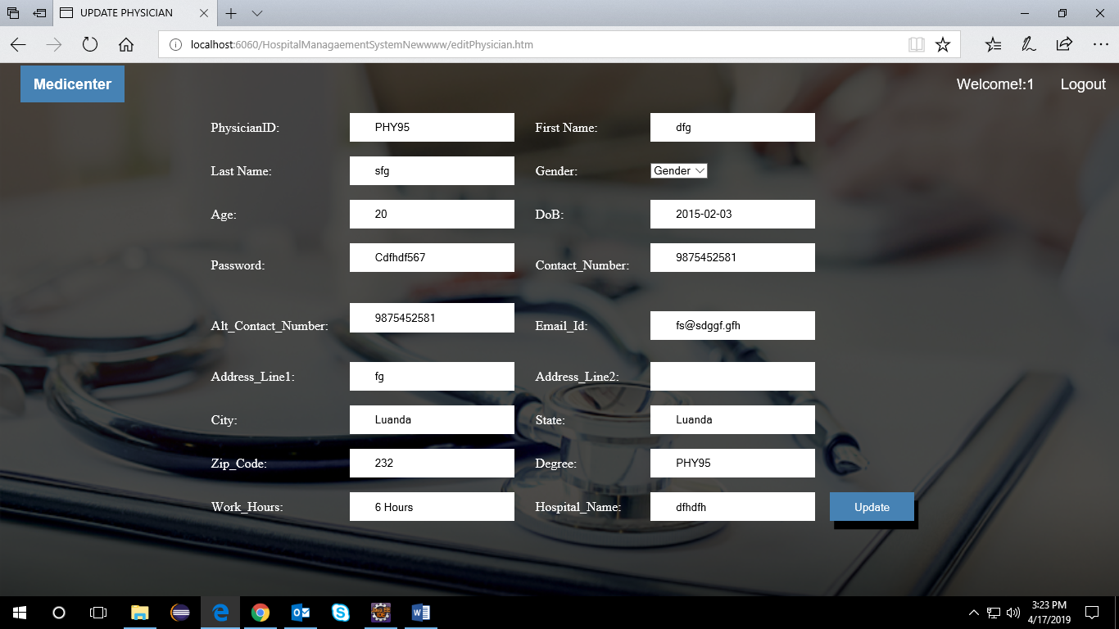

**FIG 14: Update Physician Details**

**CHAPTER-9**

**CONCLUSION & REFERENCES**

CONCLUSION:

* Identification of the drawbacks of the existing system leads to the designing of computerized system that will be compatible to the existing system with the system which is more user friendly……….
* We can improve the efficiency of the system, thus overcome the drawbacks of the existing system

REFERENCES:

* www.google.co.in(Internet Search Engine)
* www.youtube.com (internet website)
* www.stackoverflow.com
* [www.java2s.com](http://www.java2s.com)
* [www.javatpoint.com](http://www.javatpoint.com)
* [www.tutorialspoint.com](http://www.tutorialspoint.com)
* [www.w3schools.com](http://www.w3schools.com)